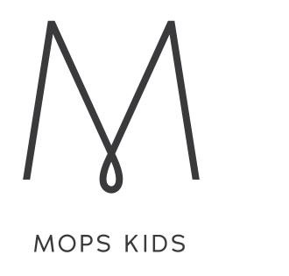
Playtime
BLACKTOWN
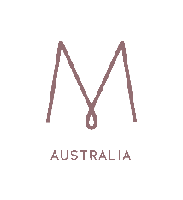
You’re Invited to Join Us:
12th Feb, 26th Feb,
12th Mar, 26th Mar,
9th April, 30th April,
14th May, 28th May,
11th June, 25th June,
23rd July,
6th Aug, 20th Aug,
3rd Sept, 17th Sept,
15th Oct, 29th Oct,
12th Nov, 26th Nov,
10th Dec.
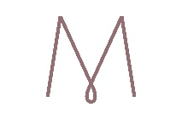
Contact: Kath 0413 084 832

MOPS meets
BLACKTOWN alternate Tuesdays to MOPS KIDS PLAYTIME
9:30 -11:30am (During School Terms)

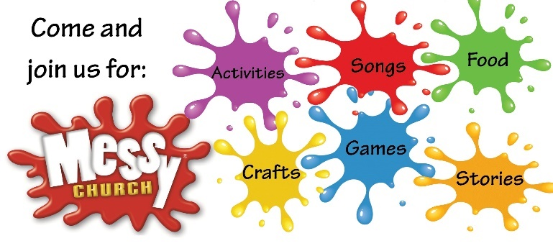

3rd Sunday of the month
4:00-6:00pm

