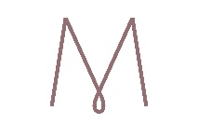
BLACKTOWN
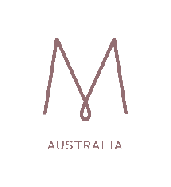
You’re Invited to Join Us:
5th Feb, 19th Feb
5th Mar, 19th Mar
2nd April
7th May, 21st May
7th June, 21st June
2nd July, 30th July
13th Aug, 27th Aug
10th Sept, 24th Sept
22nd Oct
5th Nov, 19th Nov,
3rd Dec.
Contact: Kath 0413 084 832
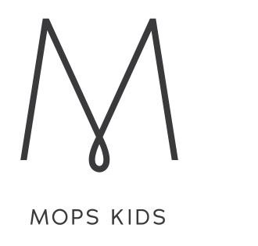
Playtime

Alternate Tuesdays to MOPS (During School Terms)
9:30 -11:30am

3rd Sunday of the month 4:00-6:00pm

